Battery Installation Instructions

- Method #1
2 x 16340 Li-ion Recharged Battery
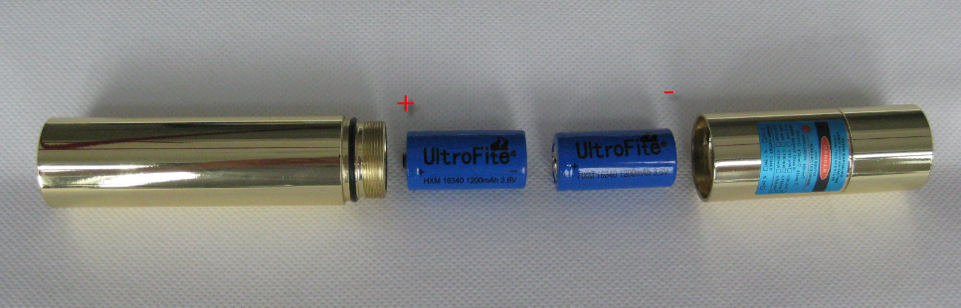

- Method #2 (Recommend)
2 x 18350 Li-ion Recharged Battery
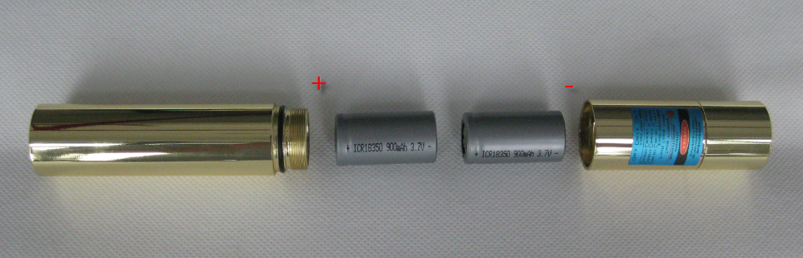

Note:
If you choose Method#2(18350 battery), please make sure the diameter of the 18350 batter is 18mm.
